Baby Evo - Design Journal

Team Members : Zachary Houghton, Zichang Liu, Kenny Wei, Wushuang Zhou

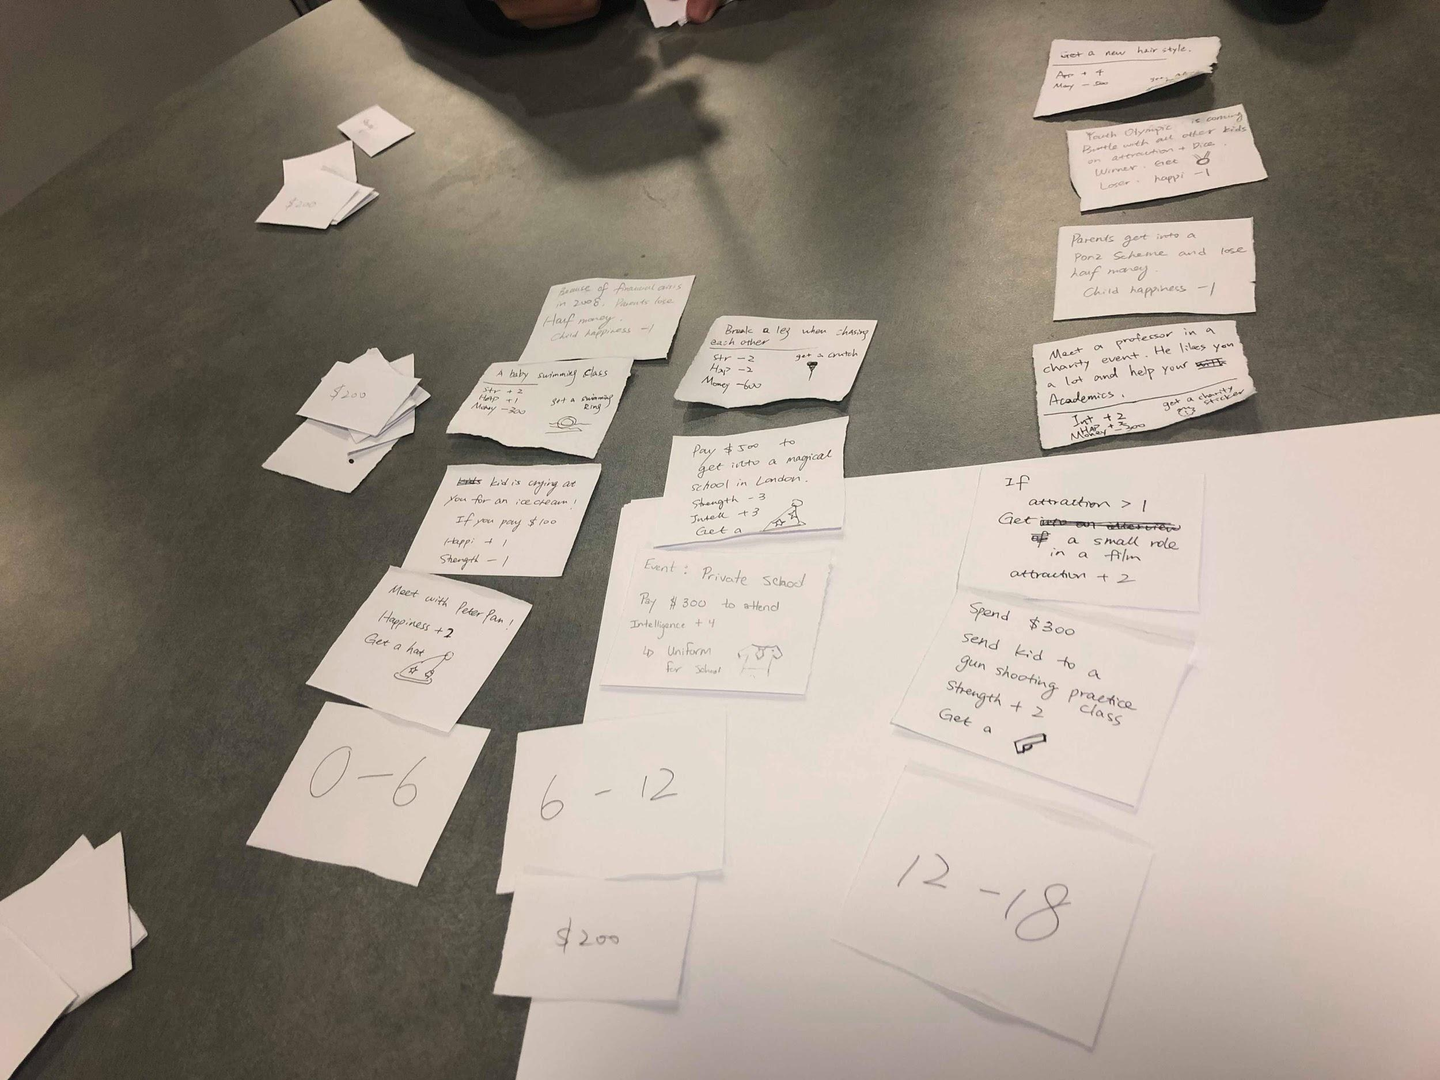

**Initial Design:**

Baby Evo was one of the winning games for the final projects for the class. The game foundation was already set from the game being an extension from the emotion game. The game however was a fair bit different from the proposed emotion game to what Baby Evo was pitched to be. With this we started to flesh out the mechanics of Baby Evo to a playable state for the upcoming class. The premise of the game was charming as it involves raising a child while also customizing what the child looks like as the game progressed. The dramatic elements were present but the mechanics of the game were quite a way off. 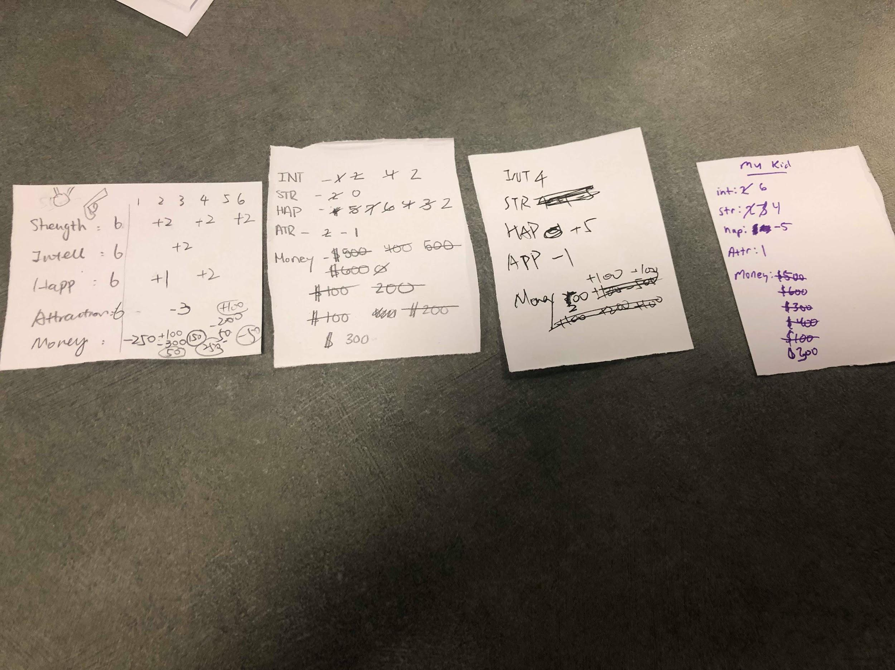

The initial mechanics were changed to have the number of turns represent the number of years that have passed for your child. This then led itself to having separate event cards that would correspond to events that would happen to your child at different age ranges. All of this was coupled with stats that your child would accumulate during their upbringing. 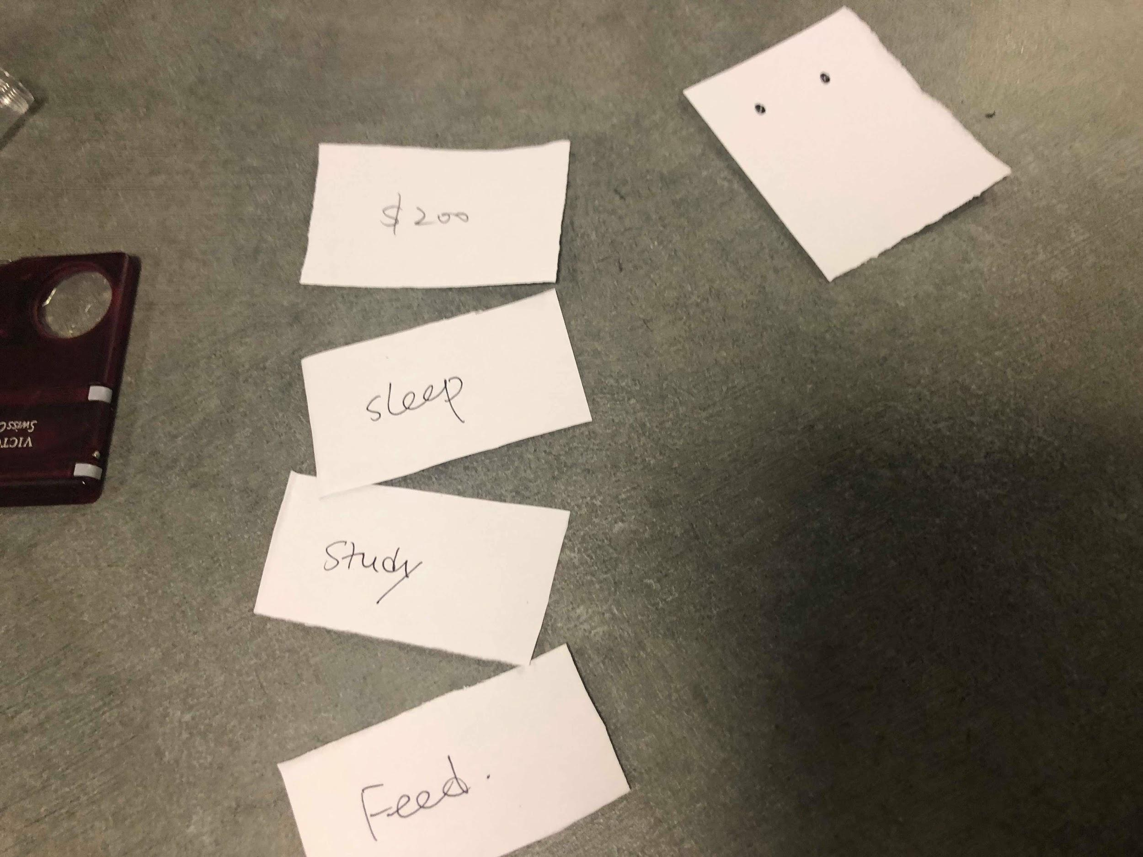

We soon realized that there was a lot of mechanics that were introduced but not fully utilized for the game. For example the stat system is mainly utilized to determine the winner in accordance to what the end cards says. Besides that there is rarely an instance where stats are used throughout the game. In addition to this, the main component of the game was being able to customize the appearance of your child with the events that occur to your child. We could see that the game needed to be fleshed out way more, but decided to playtest the game since it technically was playable and then to decide what mechanics we needed to emphasize and what problems we could outright see with the game. We could see that we would need a way to seamlessly keep track of all of our childrens stats, a way to separate casual card and event cards while making sure that they were both important to the game, and a way to customize the little avatar that is used to represent our child. In addition to this we also decided that we would need to figure out the win condition if there even is one for this game, since the ending card solution seems too reliant on random chance of whether your kid was raised right at the end of the 18 year.

**Revisions/ More Playtest:**

After the initial playtest there were many flaws that were visually present. The feedback from our playtesters also echoed the many flaws of the game. Players were confused with why stats were included into the game if they served little to no purpose in the game. They also mentioned the fact that the winner of the game is basically random so there is no point in playing the game. The final point that was made was the fact that the game basically had no player interaction, so there was no reason for players to play the game in a group. With all of this feedback there was a dire need to redesign the majority of the game from the ground up, so that was what was done.

The main premise of the game was kept so we are still developing a game that revolves around raising our child but changes were made to the win condition and the types of cards in the game. Despite all of the negative feedback, the players were still seen laughing from the stats distribution and events that occurred to their children. This put into perspective the fact that although the game mechanics in its current state were pretty bad, there was something from the narrative of the game the people enjoyed. The goal was to then to keep this central theme and build mechanics around this narrative of raising your child. First and foremost we took out the casual cards as there was little to no purpose for it to exist in the first place. This was replaced with an aging mechanic where players will roll a D4 and the outcome is the amount of skill points the player can allocate to their child to account for the fact that all of the children are aging around 3 years every time it is a player’s turn. Event cards were recreated to be simpler to understand and to have good, bad, or extremely good effects to occur. In addition to this interact cards were added to introduce a bit more player interaction. The most interesting change to this was the introduction to what happens when you win an interaction card. Essentially interact cards involve all of the player’s kids to battle to see who is the best kid. The winner of this gets a stat boost but also gets to look at the top two cards of the ending cards pile which is a pool of win conditions and then discard one of the cards. Each player will essentially be trying to discard win conditions that are not fit for their child while also trying to raise the best possible child that they can.

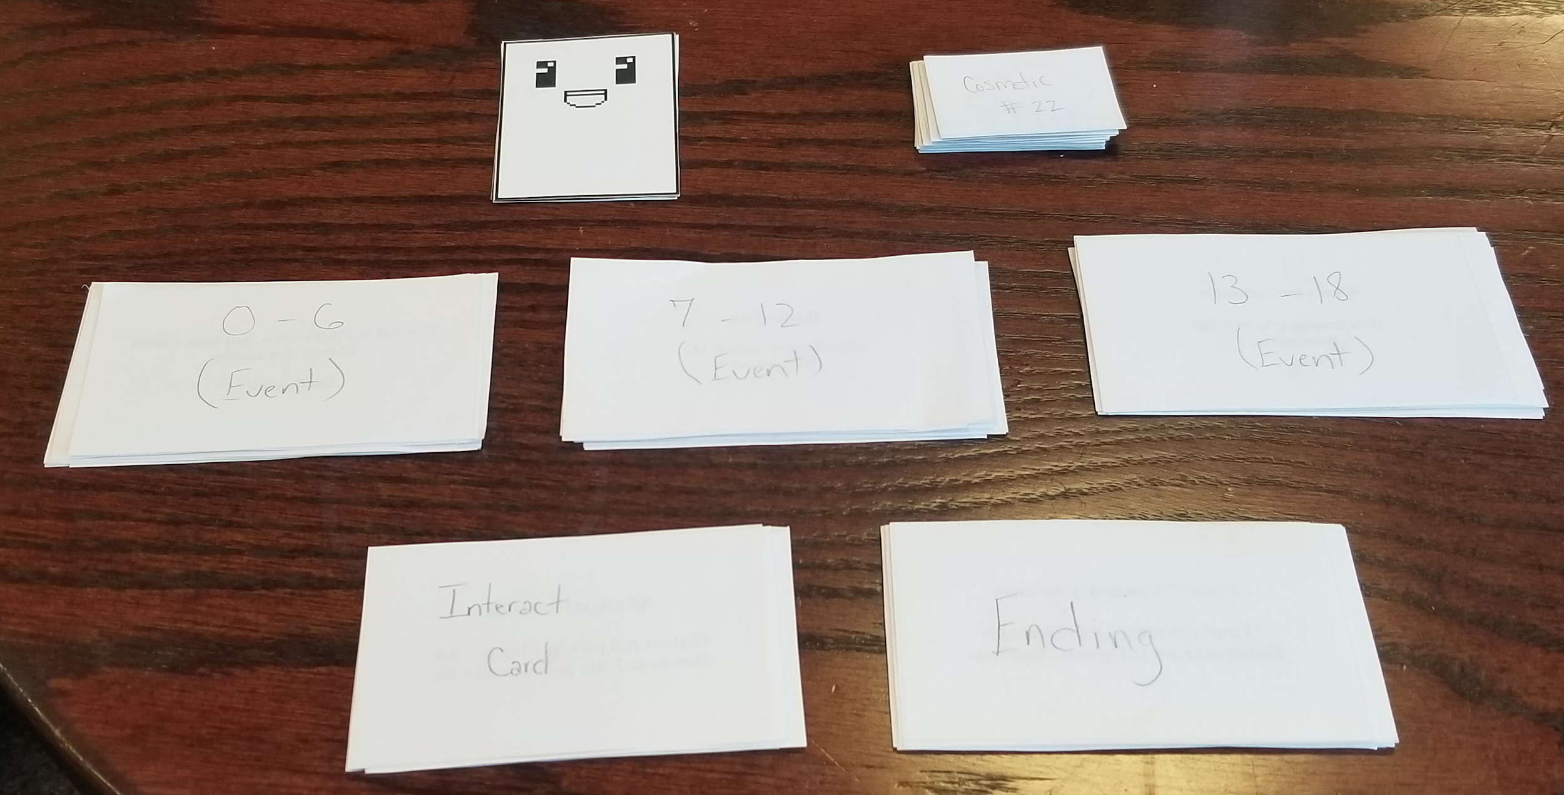

With a redesign of the current game we decided that it was time to go back into the playtesting phase and to see how our players would react with our current iteration of the game. From the playtests with our player we could see that there were still some problems with the design of the game but nowhere as bad as our initial design of the game. The main problem with this iteration of the game was fitting the gameplay of the game to consistently hitting the 15 minute mark max per play session. In addition there seems to be a need for more player agency within the game that we needed to address within a short amount of time left. The initial solution of the former problem was to streamline all of the components of the game. Basically there was around 7 or 8 piles that players had to get ready every time they wanted to play the game, along with keep track of throughout the game. In addition the cosmetic cards were hard to handle as they are all significantly smaller than a typical playing card, with all of the cards also being made with normal paper that made quickly accessing cards a difficult task. Initially there was 3 separate types of interaction cards in regards to the games that would be played, with regards to the age groups the games would mimic games that would be played in the various age groups with hand games being played from ages 0-6, discussion games being 7-12, and just a standard dice roll taking place for the final age group as players try and make the final stat distributions in the game before drawing what the win condition for the game. From a playtest it was determined that none of these were particularly interesting to the playtesters and that it was just an unnecessary time sink with players saying that they would just prefer it to be a dice roll with the addition of a stat. This change was made which resulted in cutting down on the number of piles that needed to be in the game since there would only need to be 3 piles for events for the kid, 1 interaction pile, an ending pile, and a pile that for all of the cosmetics for the kids. In addition to this we added a quick start to the rules as well as rewrote them to better fit the game with the hopes that this would also contribute to a shorter playtime.

**Final Design:**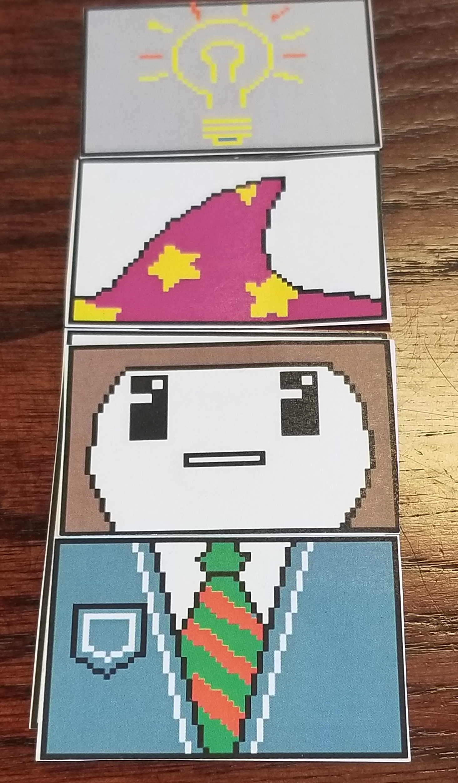

The final design of the game ended with changing some of the event cards being turning into a choice card which are essentially just cards that allow for some player choice among the events that occur to your kid. Along with this there was a change to interact cards which was stripping the stat points that used to be awarded to the winner of the interact card. This was done since it felt as though too many mechanics were baked into interact cards, while it also being the case that interact card holding too much power, from discarding an ending card as well as a giving a player stats. There was discussion about a mechanic where players would either take an event card with the potential to add stats to their child or instead have the option to reallocate all of the stats for their child that turn, but resulted in time playtime that was significantly increased from re-allocating all of the stats as well as slight confusion about the current round it would be since players weren’t necessarily guaranteed to have the same amount of event cards as each other anymore. The basic goal of creating a simulation goal was nonetheless met despite the unfortunate start of the project with the project even holding onto a part of the previous shock value from the emotion game from the endings that could occur for game. 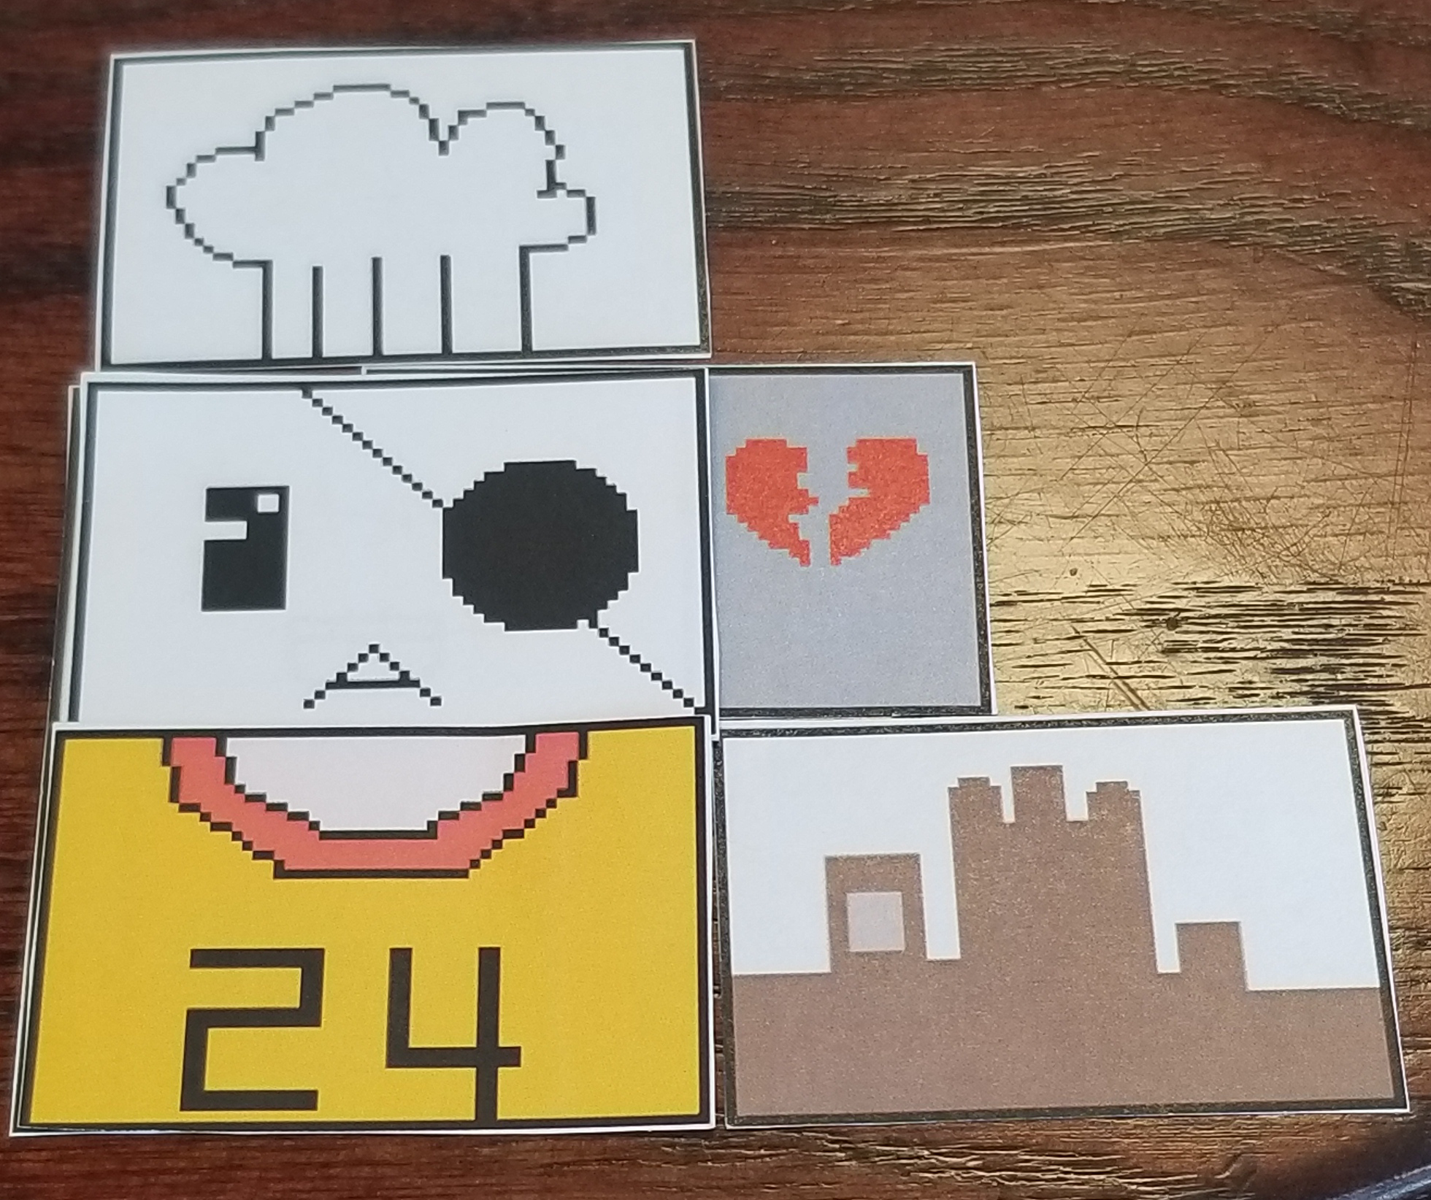

**Responsibilities:**

Zachary Houghton: Ending Card creation

Zichang Liu: Rules, Playtest Log

Kenny Wei: Photo Journal, Rules, Playtest Log

Wushuang Zhou: Art

Everyone : Playtesting, Design, Pitch Presentation, Event creation